DIS-US-Ledger Drawing

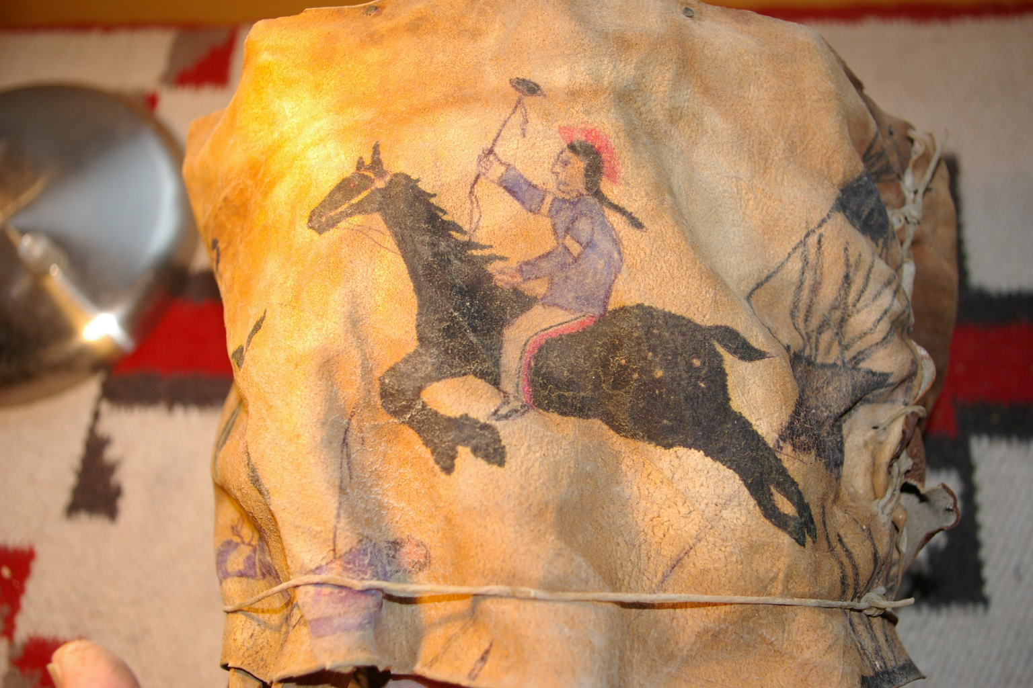 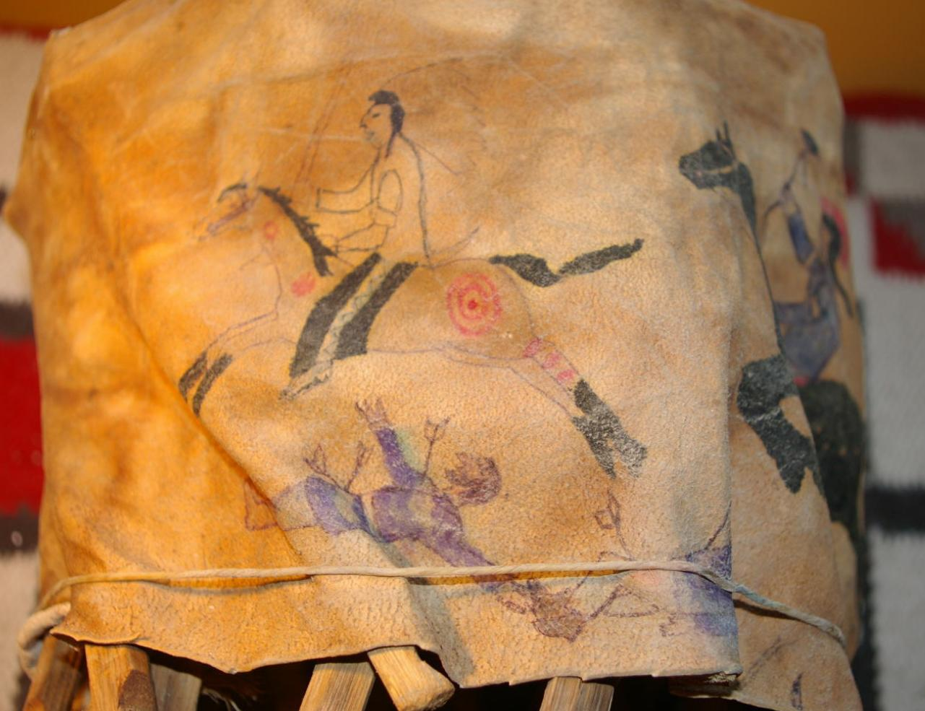 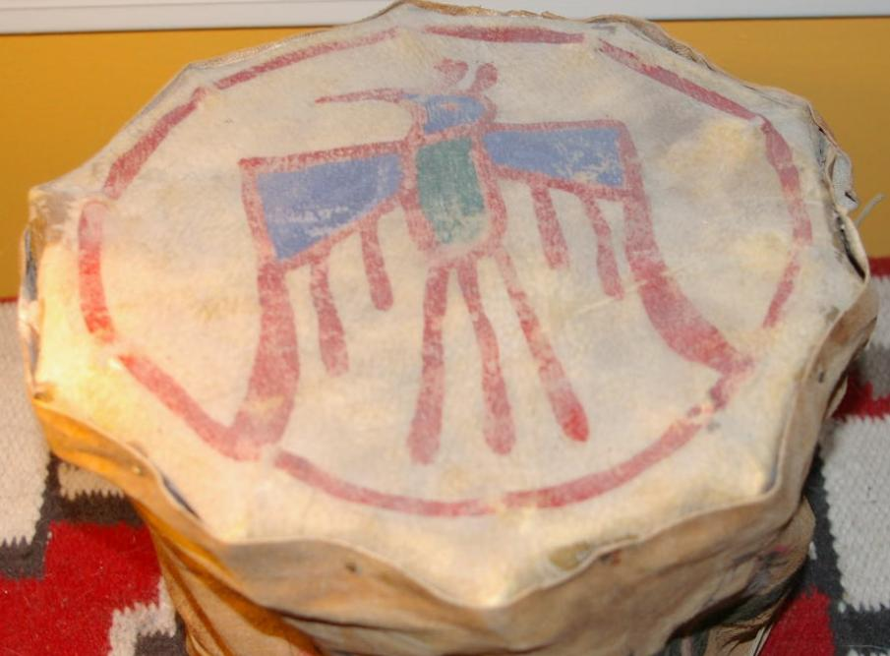 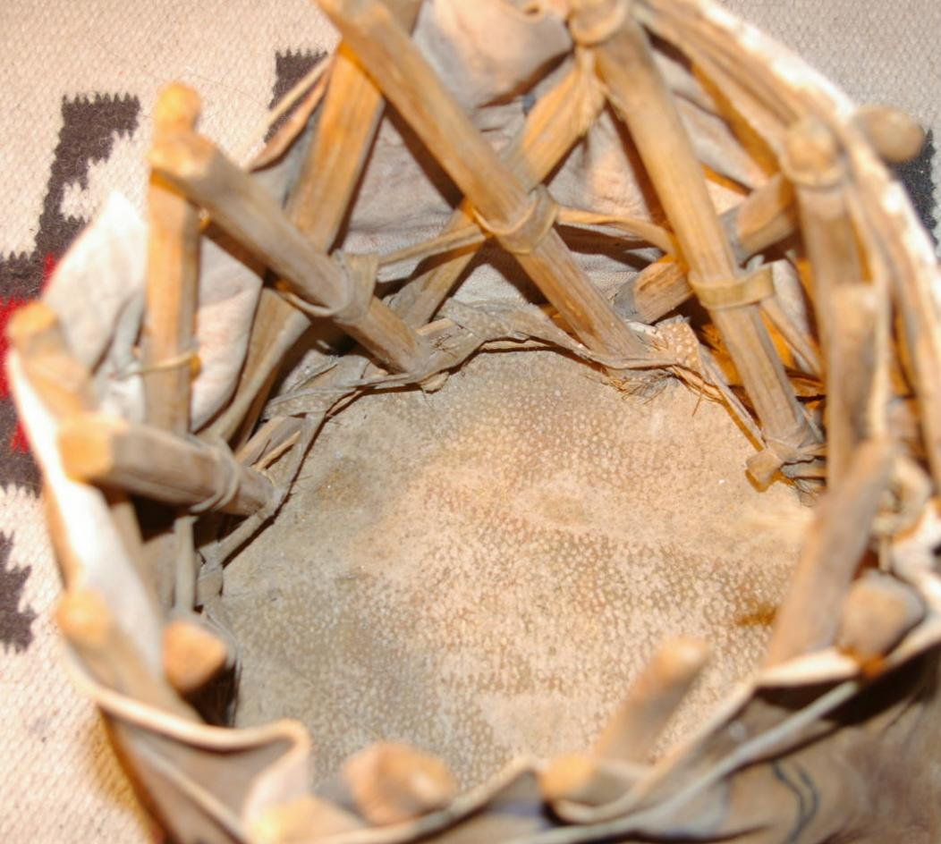 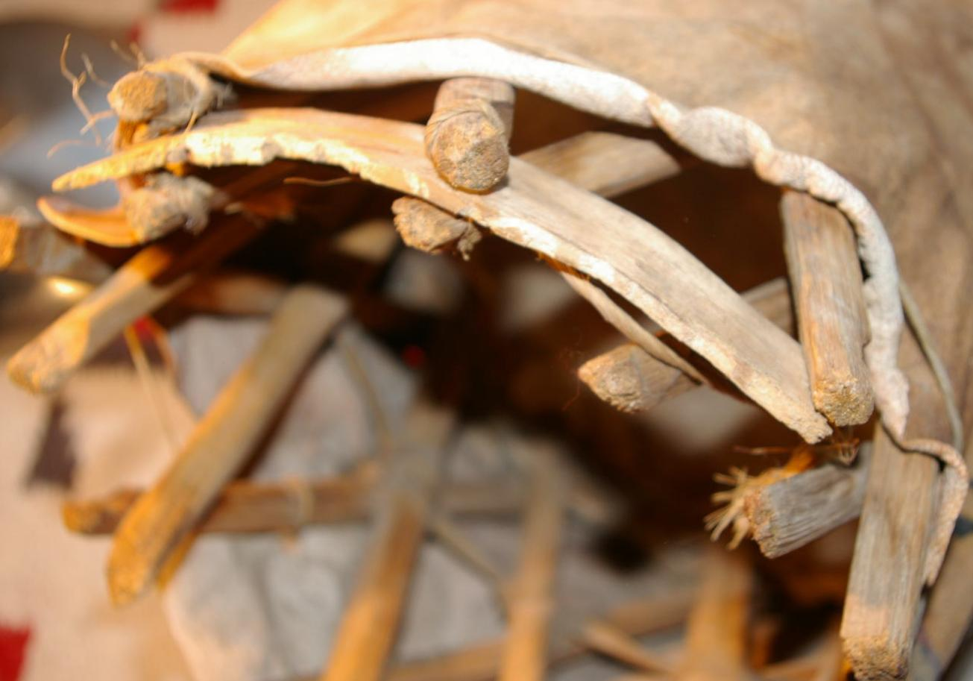

|  |  |
| --- | --- |
| ORDER DATEApr 17, 2016 | ORDER TOTAL  US $150.00  + US $15.00  shipping  **Order ** Indian Stool,Ledger Paintings,,Vintage,Old,Antique\*\*** [Leave feedback - ORDER DATE Apr 17, 2016](http://feedback.ebay.com/ws/eBayISAPI.dll?LeaveFeedbackShow&useridto=granitestatetrade&transactID=0&item=131779500370&_trksid=p2057872.m2749.l2665)[View order details](http://payments.ebay.com/ws/eBayISAPI.dll?ViewPaymentStatus&transId=0&itemid=131779500370&_trksid=p2057872.m2749.l2673) - ORDER DATE Apr 17, 2016  [More actions - ORDER DATE Apr 17, 2016](http://www.ebay.com/myb/PurchaseHistory) |

1 item sold by [granitestatetrade](http://www.ebay.com/usr/granitestatetrade?_trksid=p2057872.m2749.l2754)

|  |  |  |  |  |  |
| --- | --- | --- | --- | --- | --- |
| [** Indian Stool,Ledger Paintings,,Vintage,Old,Antique**](http://www.ebay.com/itm/131779500370?_trksid=p2057872.m2749.l2649&ssPageName=STRK%3AMEBIDX%3AIT)  ( 131779500370 )  Delivered on Tue, Apr 19  Tracking number: [**Tracking number**9505514791116109006536](javascript:;)  [Add note](javascript:;) | | | | ITEM PRICE:  US $150.00 |  |
|  | ORDER DATEApr 10, 2016 | ORDER TOTAL  US $1,550.00  + US $35.00  shipping  **Order Ledger Drawing Native American Indian Very Nice,VINTAGE Ledger Drawing Native American Indian Estate Find,Ledger Drawing Native American Indian Killing Soldiers Estate Sale Find,Ledger Drawing Native American Indian Fighting Soldiers Estate Sale Find,Ledger Drawing Native American Indian Battling Soldiers Estate Sale Find** [View order details - ORDER DATE Apr 10, 2016](http://payments.ebay.com/ws/eBayISAPI.dll?ViewPaymentStatus&transId=1304370973013&itemid=231909000466&_trksid=p2057872.m2749.l2673)[Contact seller](http://contact.ebay.com/ws/eBayISAPI.dll?ShowSellerFAQ&requested=onepeople43&iid=231909000466&redirect=0&_trksid=p2057872.m2749.l2652) - ORDER DATE Apr 10, 2016  [More actions - ORDER DATE Apr 10, 2016](http://www.ebay.com/myb/PurchaseHistory) |  | | |

5 items sold by [onepeople43](http://www.ebay.com/usr/onepeople43?_trksid=p2057872.m2749.l2754)

|  |  |  |
| --- | --- | --- |
| [Ledger Drawing Native American Indian Very Nice](http://www.ebay.com/itm/231909000466?_trksid=p2057872.m2749.l2649&ssPageName=STRK%3AMEBIDX%3AIT)  ( 231909000466 )  Estimated delivery Thu, Apr 14 - Mon, Apr 18  [Add note](javascript:;) | ITEM PRICE:  US $250.00 | **Item Ledger Drawing Native American Indian Very Nice Orders 231909000466-0-1304370973013**[Leave feedback](http://feedback.ebay.com/ws/eBayISAPI.dll?LeaveFeedbackShow&useridto=onepeople43&transactID=1304370973013&item=231909000466&_trksid=p2057872.m2749.l2665)[Return this item](http://postorder.ebay.com/Return/ReturnViewSelectedItem?transactionId=1304370973013&itemId=231909000466&_trksid=p2057872.m2749.l3185)  [More actions](http://www.ebay.com/myb/PurchaseHistory) |

|  |  |  |
| --- | --- | --- |
| [VINTAGE Ledger Drawing Native American Indian Estate Find](http://www.ebay.com/itm/371596778648?_trksid=p2057872.m2749.l2649&ssPageName=STRK%3AMEBIDX%3AIT)  ( 371596778648 )  Estimated delivery Thu, Apr 14 - Mon, Apr 18  [Add note](javascript:;) | ITEM PRICE:  US $250.00 | **Item VINTAGE Ledger Drawing Native American Indian Estate Find Orders 371596778648-0-823333870024**[Leave feedback](http://feedback.ebay.com/ws/eBayISAPI.dll?LeaveFeedbackShow&useridto=onepeople43&transactID=823333870024&item=371596778648&_trksid=p2057872.m2749.l2665)[Return this item](http://postorder.ebay.com/Return/ReturnViewSelectedItem?transactionId=823333870024&itemId=371596778648&_trksid=p2057872.m2749.l3185)  [More actions](http://www.ebay.com/myb/PurchaseHistory) |

|  |  |  |
| --- | --- | --- |
| [Ledger Drawing Native American Indian Killing Soldiers Estate Sale Find](http://www.ebay.com/itm/371596785063?_trksid=p2057872.m2749.l2649&ssPageName=STRK%3AMEBIDX%3AIT)  ( 371596785063 )  Estimated delivery Thu, Apr 14 - Mon, Apr 18  [Add note](javascript:;) | ITEM PRICE:  US $350.00 | **Item Ledger Drawing Native American Indian Killing Soldiers Estate Sale Find Orders 371596785063-0-823333869024**[Leave feedback](http://feedback.ebay.com/ws/eBayISAPI.dll?LeaveFeedbackShow&useridto=onepeople43&transactID=823333869024&item=371596785063&_trksid=p2057872.m2749.l2665)[Return this item](http://postorder.ebay.com/Return/ReturnViewSelectedItem?transactionId=823333869024&itemId=371596785063&_trksid=p2057872.m2749.l3185)  [More actions](http://www.ebay.com/myb/PurchaseHistory) |

|  |  |  |
| --- | --- | --- |
| [Ledger Drawing Native American Indian Fighting Soldiers Estate Sale Find](http://www.ebay.com/itm/371596787094?_trksid=p2057872.m2749.l2649&ssPageName=STRK%3AMEBIDX%3AIT)  ( 371596787094 )  Estimated delivery Thu, Apr 14 - Mon, Apr 18  [Add note](javascript:;) | ITEM PRICE:  US $350.00 | **Item Ledger Drawing Native American Indian Fighting Soldiers Estate Sale Find Orders 371596787094-0-823333868024**[Leave feedback](http://feedback.ebay.com/ws/eBayISAPI.dll?LeaveFeedbackShow&useridto=onepeople43&transactID=823333868024&item=371596787094&_trksid=p2057872.m2749.l2665)[Return this item](http://postorder.ebay.com/Return/ReturnViewSelectedItem?transactionId=823333868024&itemId=371596787094&_trksid=p2057872.m2749.l3185)  [More actions](http://www.ebay.com/myb/PurchaseHistory) |

|  |  |  |
| --- | --- | --- |
| [Ledger Drawing Native American Indian Battling Soldiers Estate Sale Find](http://www.ebay.com/itm/371596788954?_trksid=p2057872.m2749.l2649&ssPageName=STRK%3AMEBIDX%3AIT)  ( 371596788954 )  Estimated delivery Thu, Apr 14 - Mon, Apr 18  [Add note](javascript:;) | ITEM PRICE:  US $350.00 | **Item Ledger Drawing Native American Indian Battling Soldiers Estate Sale Find Orders 371596788954-0-823333871024**[Leave feedback](http://feedback.ebay.com/ws/eBayISAPI.dll?LeaveFeedbackShow&useridto=onepeople43&transactID=823333871024&item=371596788954&_trksid=p2057872.m2749.l2665)[Return this item](http://postorder.ebay.com/Return/ReturnViewSelectedItem?transactionId=823333871024&itemId=371596788954&_trksid=p2057872.m2749.l3185)  [Mo](http://www.ebay.com/myb/PurchaseHistory) |